**Week 7**

**11. ReactJS – HOL**

**FILE STRUCTURE  
  
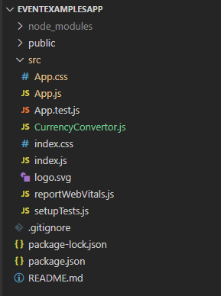**

**CODE**

*C:\Users\User\Desktop\eventexamplesapp\src\App.js*

import React, { Component } from 'react';

import CurrencyConvertor from './CurrencyConvertor';

class EventExample extends Component {

  constructor(props) {

    super(props);

    this.state = {

      counter: 0

    };

  }

  increment = () => {

    this.setState(

      prevState => ({ counter: prevState.counter + 1 }),

      () => {

        this.sayHello();

        this.staticMessage();

      }

    );

  };

  sayHello = () => {

    alert("Hello! Member1");

  };

  staticMessage = () => {

    console.log("Static message after hello");

  };

  decrement = () => {

    this.setState(prevState => ({ counter: prevState.counter - 1 }));

  };

  sayWelcome = (msg) => {

    alert(msg);

  };

  clickOnMe = () => {

    alert("I was clicked");

  };

  render() {

    return (

      <div style={{ margin: '20px' }}>

        <h2>{this.state.counter}</h2>

        <button onClick={this.increment}>Increment</button>

        <div style={{ marginTop: '5px' }}>

          <button onClick={this.decrement}>Decrement</button>

        </div>

        <div style={{ marginTop: '10px' }}>

          <button onClick={() => this.sayWelcome("welcome")}>Say welcome</button>

        </div>

        <div style={{ marginTop: '5px' }}>

          <button onClick={this.clickOnMe}>Click on me</button>

        </div>

        <div style={{ marginTop: '30px' }}>

          <CurrencyConvertor />

        </div>

      </div>

    );

  }

}

export default EventExample;

*C:\Users\User\Desktop\eventexamplesapp\src\CurrencyConvertor.js*

import React, { useState } from 'react';

const CurrencyConvertor = () => {

  const [amount, setAmount] = useState('');

  const [currency, setCurrency] = useState('');

  const handleSubmit = (e) => {

    e.preventDefault();

    if (currency.toLowerCase() === 'euro') {

      const result = parseFloat(amount) * 80;

      alert(`Converting to Euro Amount is ${result}`);

    } else {

      alert("Unsupported currency");

    }

  };

    return (

    <div>

      <h1 style={{ color: 'green' }}>Currency Convertor!!!</h1>

      <form onSubmit={handleSubmit} style={{ display: 'flex', flexDirection: 'column', maxWidth: '300px' }}>

        <label style={{ marginBottom: '10px' }}>

          Amount:

          <input

            type="number"

            value={amount}

            onChange={(e) => setAmount(e.target.value)}

            required

            style={{ marginLeft: '10px' }}

          />

        </label>

        <label style={{ marginBottom: '15px' }}>

          Currency:

          <textarea

            value={currency}

            onChange={(e) => setCurrency(e.target.value)}

            required

            style={{ marginLeft: '10px' }}

          />

        </label>

        <div style={{ display: 'flex', justifyContent: 'center' }}>

          <button type="submit">Submit</button>

        </div>

      </form>

    </div>

  );

};

export default CurrencyConvertor;

**OUTPUT**

